Perform Buffer Overflow Attack to Gain Access to a Remote System
A buffer is an area of adjacent memory locations allocated to a program or application to handle it runtime data. Buffer overflow or overrun is a common vulnerability in applications or programs that accepts more data than the allocated buffer. Attackers exploit a buffer overflow vulnerability to inject malicious code into the buffer to damage files, modify program data, access critical information etc.

The lab demonstrates the exploitation procedure applied to a vulnerable server running on the victim’s system. The vulnerable server is attached to immunity debugger.
Exploited this server using malicious scripts to gain access to the victim’s system.
Methodology
- On the target machine, started the Vulnserver
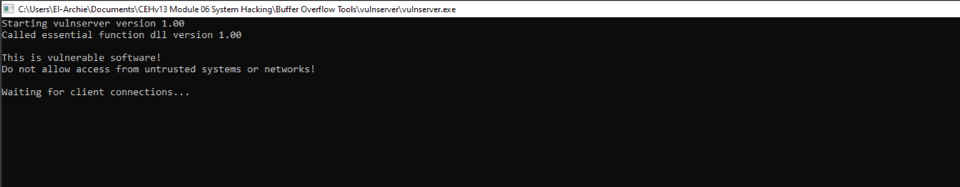
- Run and started the immunity debugger.

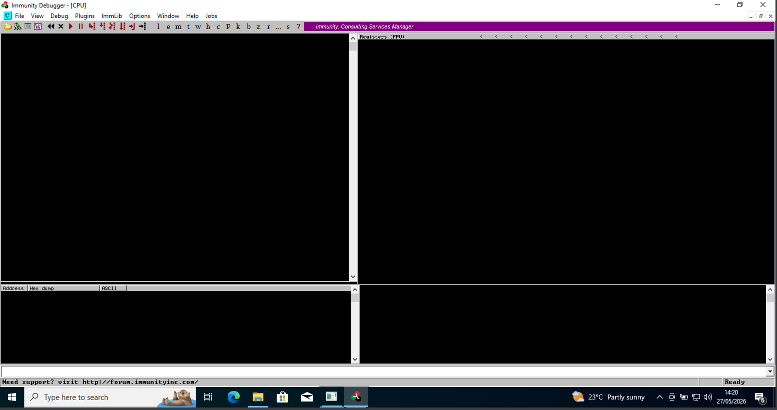
- Selected and attached the vulnserver as shown below.
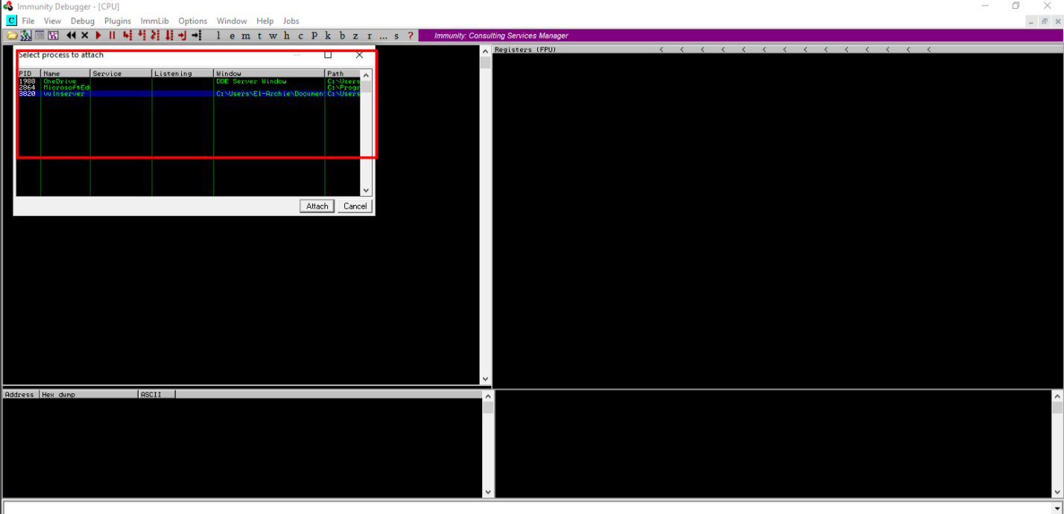
- The vulnserver is attached but paused

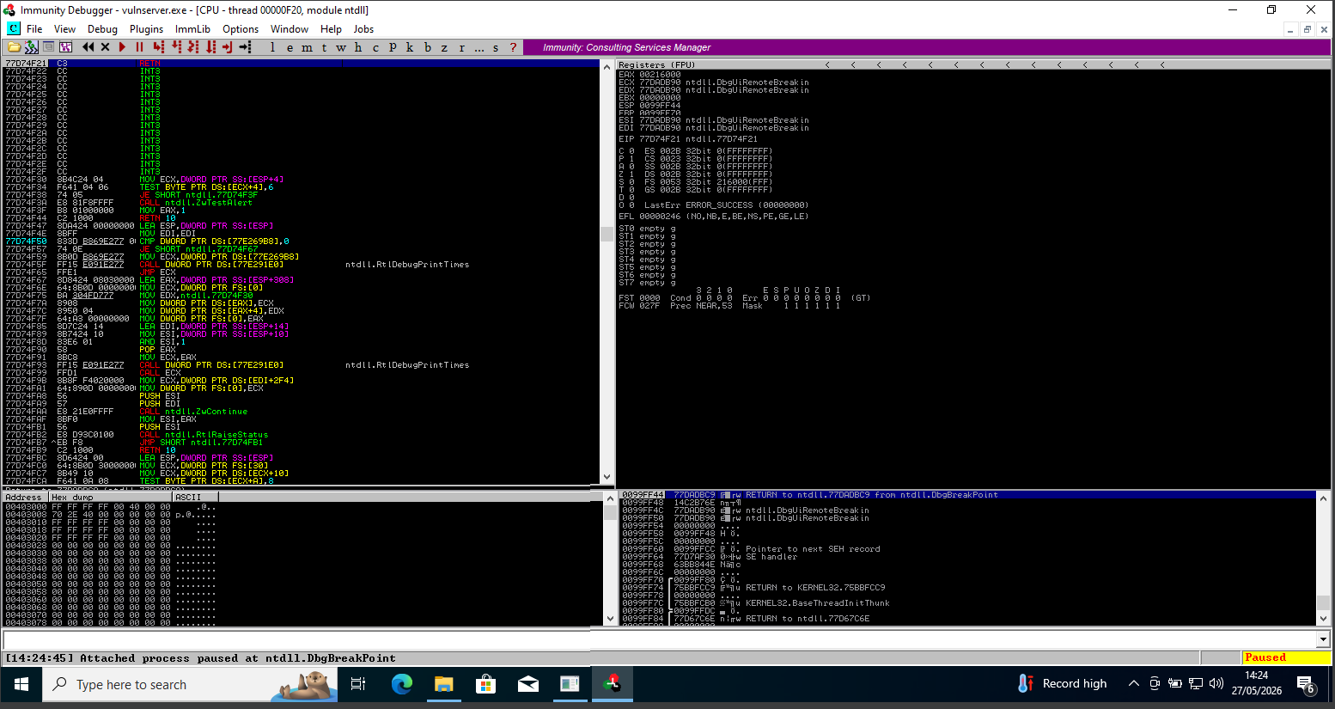

- Run the program icon to run the Immunity Debugger
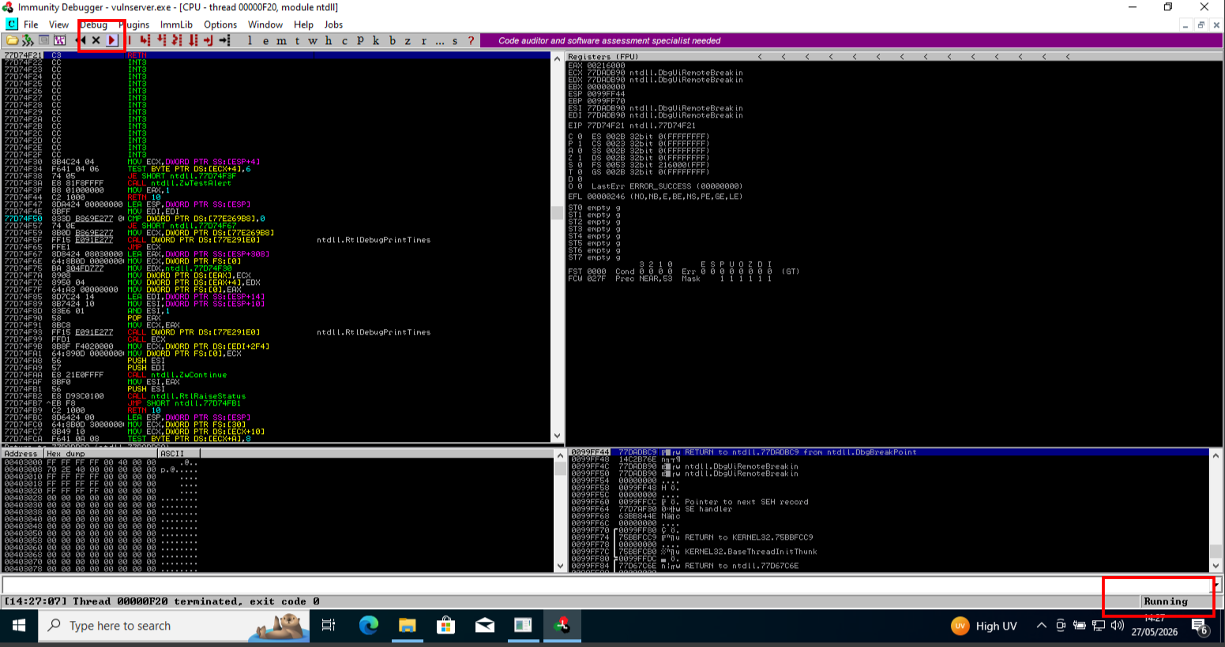
- Switcher to my attacker machine (Kali Linux 2026.1) and established a connection using Netcat command to establish a connection with the target vulnerable server to identify the services and functions provided by the server.

Command used: nc -nv <target ip:9999> 9999 is target port.

- A Welcome to Vulnerable Server message appeared; type HELP to view a list of valid commands displayed.
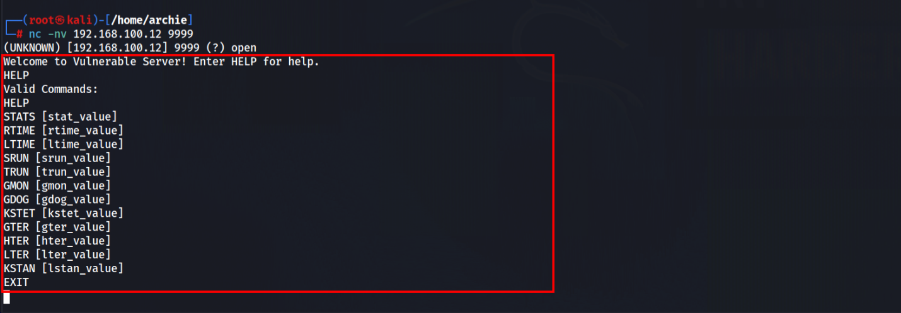
- Generated spike templates and performed spiking.

Spike templates define the package formats used for communicating with the vulnerable server.

- Used nano text editor.
s_readline();
s_string("STATS ");
s_string_variable("0");

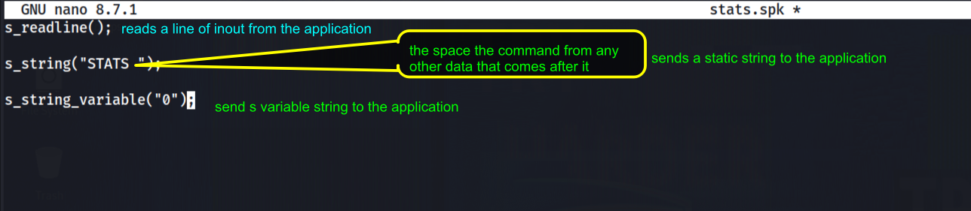
Command used: nano stats.spk

- Sent the package to the vulnerable server.
Command used: generic_send_tcp <target ip 9999> stats.spk 0 0
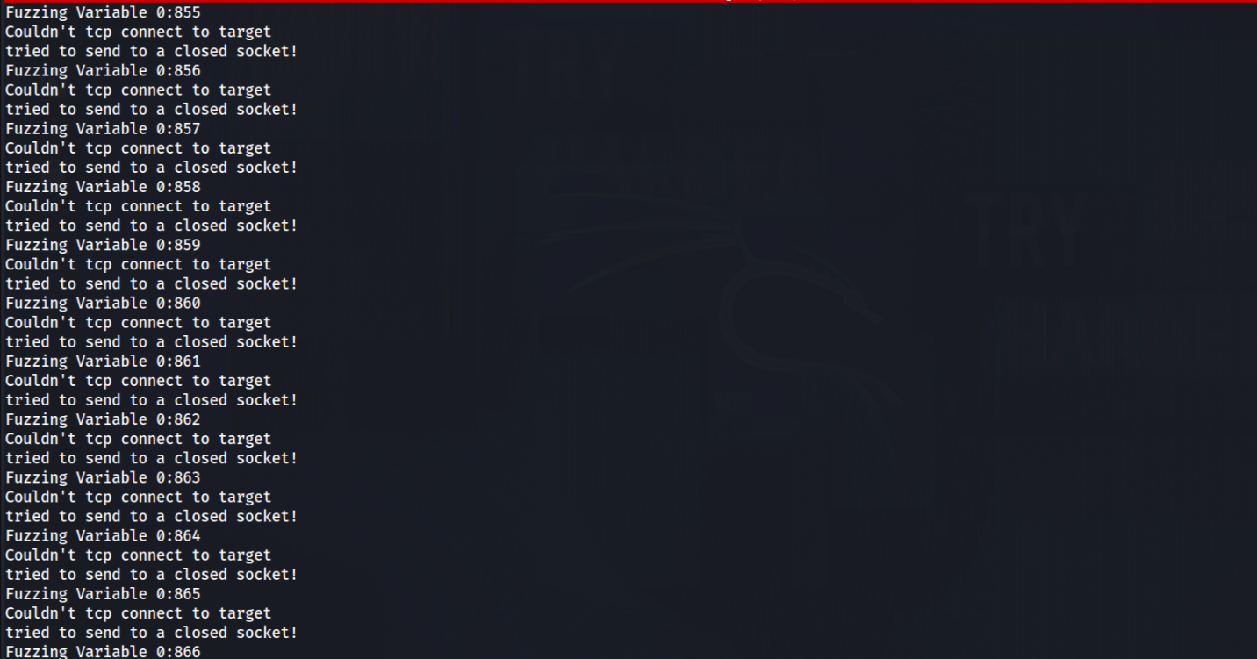
- Left the running and switched the target machine (Windows 10), and in the immunity debugger window the process status was still running, which indicated the that the STATS function is not vulnerable to buffer overflow.
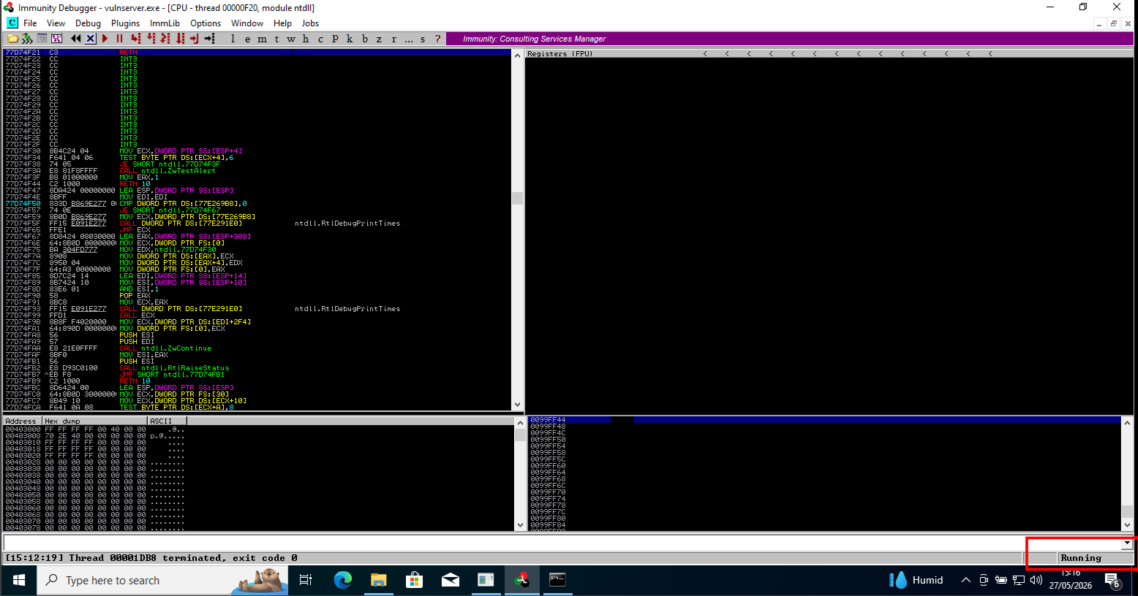
- Repeated the same process with the TRUN function.
This sends large amount of data.
s_readline();
s_string("TRUN ");
s_string_variable("0");

command used: nano trun.spk
- sent the packages to the vulnerable server
command use: generic_send_tcp 192.168.100.12 9999 trun.spk 0 0
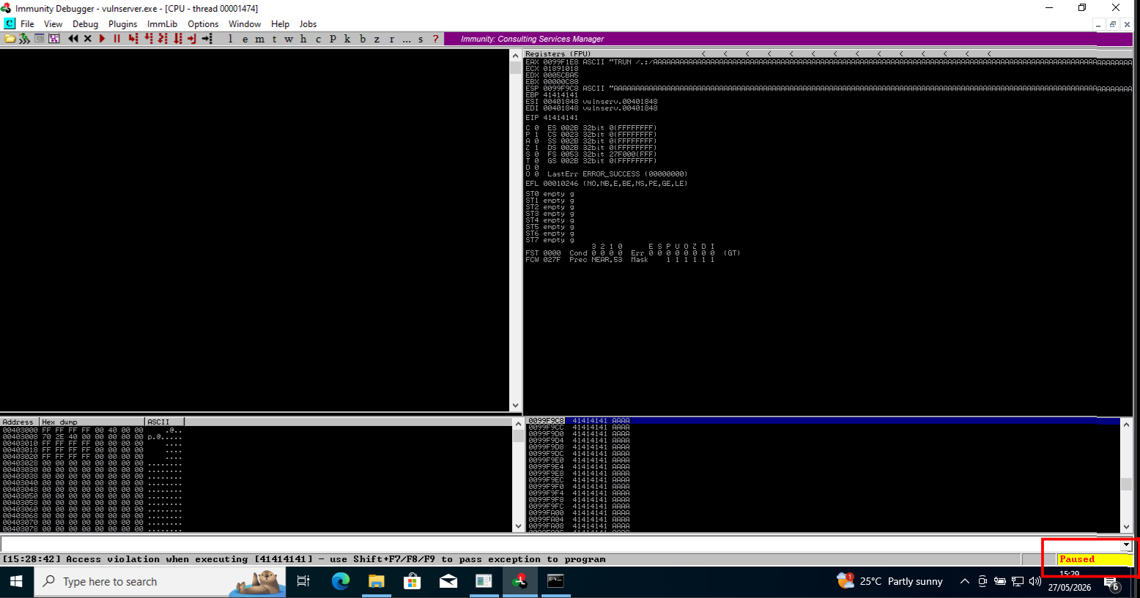
The process is paused, which means the TRUN function of the vulnerable server is having buffer overflow vulnerability.
Spiking the TRUN function overwritten stack registers such EAX, ESP, EBP and EIP. Overwriting the EIP register could allow us to gain shell access to the target system.

At the right of the window, the EAX, ESP, EBP and EIP registers were overwritten with ASCII value “A”
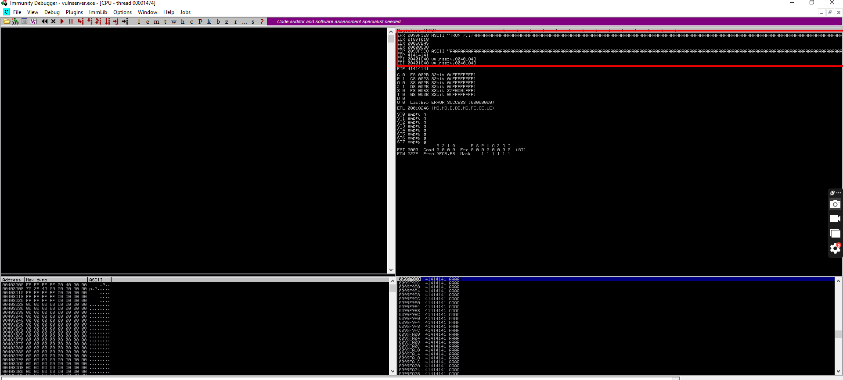
- After identifying the buffer overflow vulnerability in the target server, we needed to perform fuzzing.
Fuzzing sends large amount of data to the target server so that it experiences buffer overflow and overwrites the EIP register.
- Closed the immunity debugger and the vulnerable server process.
- Relaunched both the immunity debugger and the vulnerable server as an administrator.
Attached the vulnsever process to immunity debugger and clicked run program icon in the toolbar to run immunity debugger.
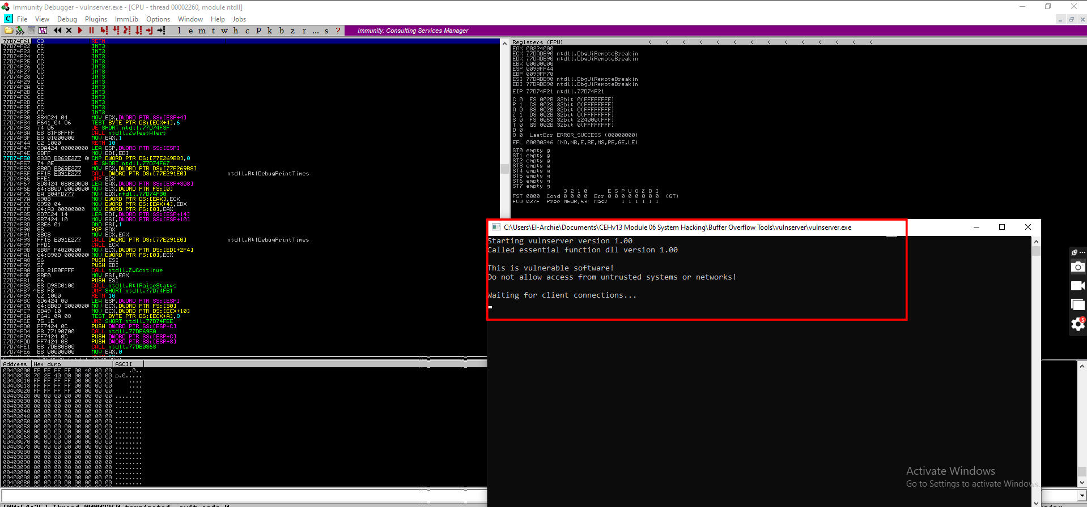

- Switched back to my attacker’s machine.
Opened the folder and navigated to the network (Browse network)
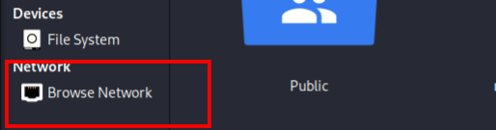

- Network window appeared; pressed Ctrl+L. The location field appeared; typed smb://<target ip> and pressed ENTER to access the windows 10 shared folders.
smb://192.168.100.12/c$/Users/El-Archie/Documents
copied the script folder and pasted it Kali Linux desktop.

- To perform fuzzing, I run the python script.
Fuzz.py
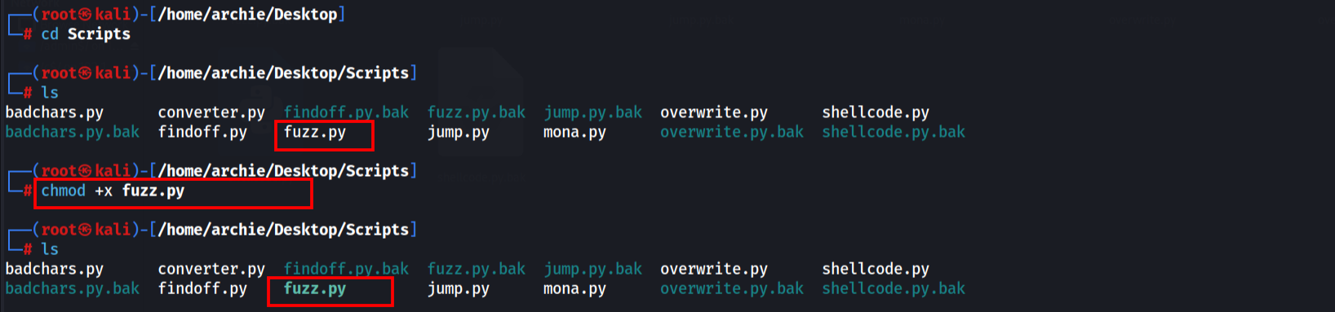
- Run ./fuzz.py python fuzzing script against the target machine.
- Closed both the immunity debugger and the vulnerable server process.

Through Fuzzing, we were able to overwrite the EIP register with 1 to 5100 bytes of data.

Now I used the pattern_create Ruby tool to generate random bytes of data.

- Re-launched both the vulnerable server and Immunity Debugger as an administrator. Attached the vulnserver process to immunity debugger and run the program.

- In my attacker’s machine, run the following command:
/usr/share/Metasploit-framework/tools/exploit/pattern_create.rb -L 10400

- The command generated a random piece of bytes; right clicked on it and copied.
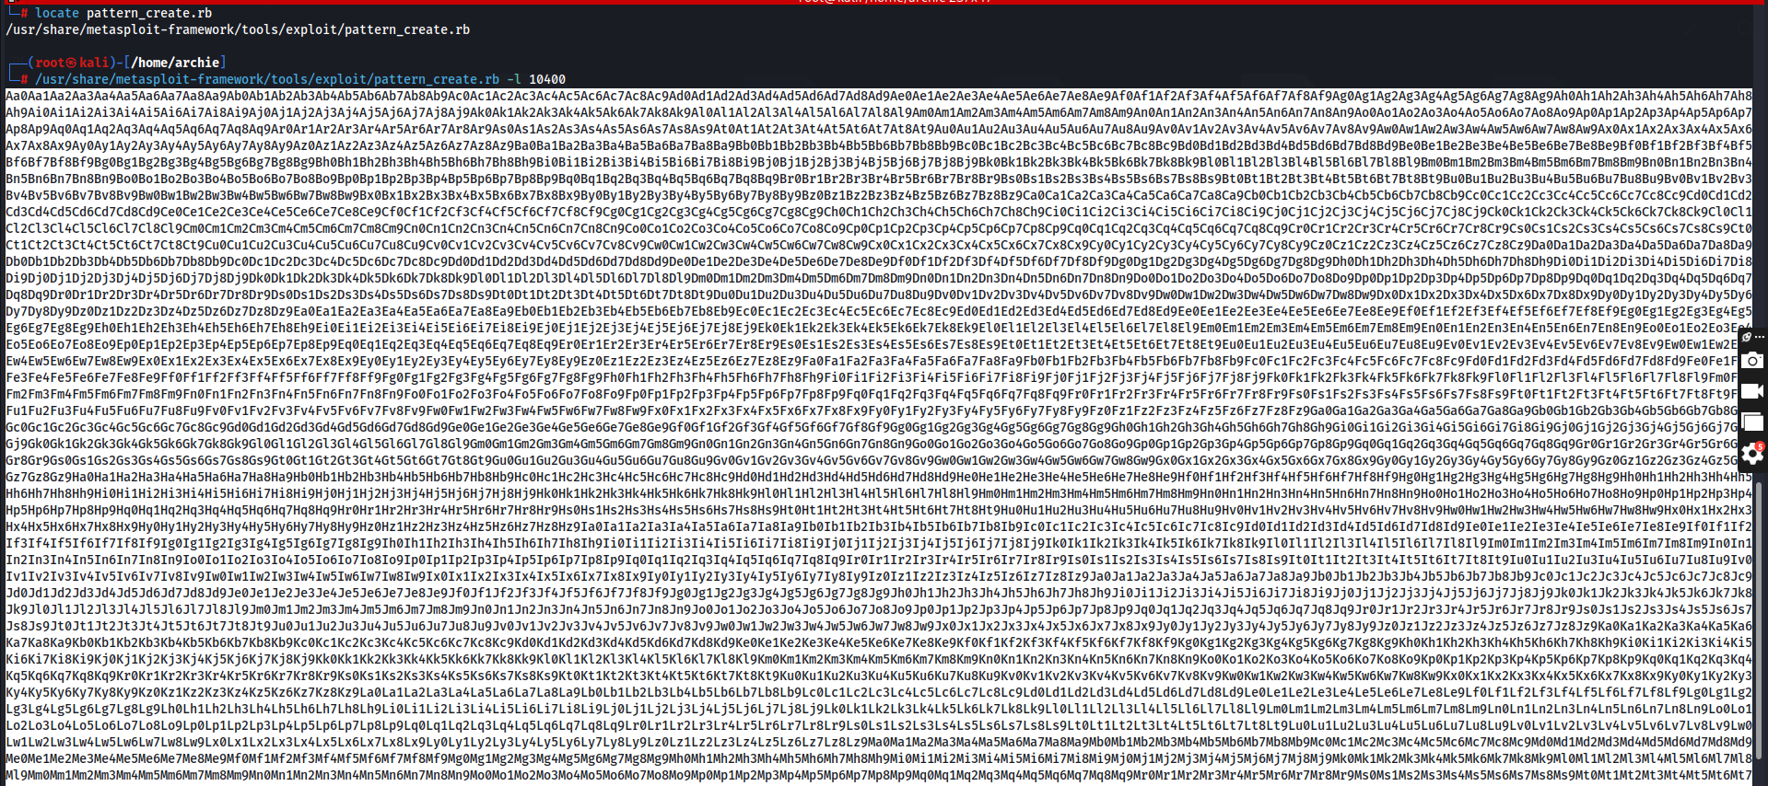
- Run nano findoff.py, to create and edit the file.
A python script file appeared; replaced the code with the inverted commas in the offset variable with the copied code.
- Made findoff.py an executable python script by running the chmod +x command.
When the script is executed, it sends random bytes of data to the target vulnerable server, causing a buffer overflow in the stack.
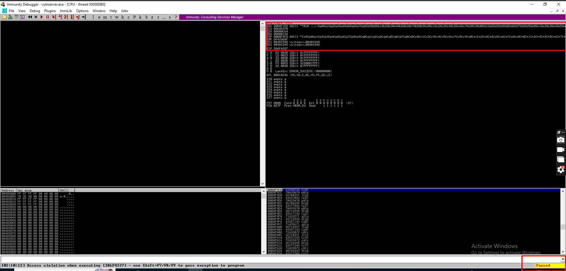

In the immunity Debugger window, the EIP register is overwritten with random bytes.

